Week 5 Java Library Management

Robert Brenckman
Charter Oak State College
ITE 215: Software Develop Method & Languages
COSC_ITE215012526FACR
John Rusnak
11/30/2025

Assignment Instructions:
You are required to develop a Library Management System that allows users to perform the following tasks:
- Add new books to the library.
- Register new members.
- Issue books to members.
- Return books to the library.
- Search for books by title, author, or ISBN.
- List all books currently issued to members.
- Save and load the library data from a file.

Assignment Requirements:
- Classes and Objects: Create classes for Book, Member, and Library.
  - See attached files.
- Data Structures: Use appropriate data structures (e.g., ArrayList, HashMap) to manage books and members.
  - Books and Members are stored into Lists and HashMaps appropriately where perform lookups. Members and Inventory can be accessed by their id#, which for this application also serves as their index within the array.
  - A more robust solution would be to store then in a dictionary by their id #, but for this example a list is fine, as long as the json file isn’t manipulated out of order.
- OOP Principles: Demonstrate the use of inheritance, encapsulation, and polymorphism where appropriate.
  - Inheritance was used to create the LibraryException class to provide custom exceptions when an error occurs, such as returning a book that wasn’t issued.
  - Several classes act as management classes that wrap collections to maintain their integrity.
- Exception Handling: Implement exception handling for scenarios such as issuing a book that is already issued, returning a book that is not issued, or searching for a non-existent book.
  - See attached files.
- File I/O: Implement functionality to save and load library data to/from a file.
  - Menu Options 7 & 8, but also done during any changes to the state.
- User Interface: Provide a simple command-line interface to interact with the system.
  - See screenshots below.

Add Books

Users can add new books to the library. These are added to the BookCollection object, which manages the library’s inventory. This is then saved to disk as a json file.
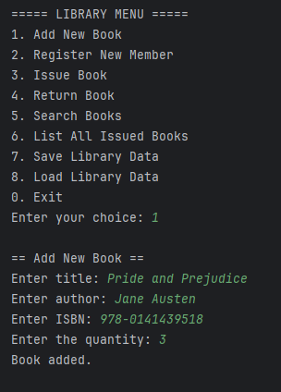

Register Members

New members can be registerd. These are added to the MemberCollection object, which manages the library’s members. This is then saved to disk as a json file.
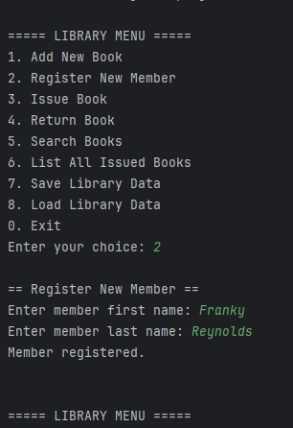

Issue Books

This menu allows a user to check out a book. It uses the MemberID # and the InventoryID# to issue the book. The idea is that the librarian would use a barcode scanner to scan the ID-Tag to input the data.
The CheckoutDate and memberID are stored within the book’s inventory json to easily note that the book is checked out. This is transferred to the history upon return of the book.
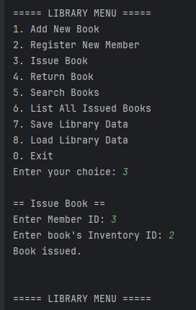
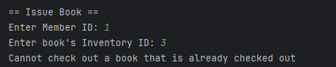
Exception Handling if book already checked out

Return Books

This menu allows a user to return a book. The only required data is the book’s Inventory ID #, which would be scanned in via barcode scanner or typed in manually.
This adds a record to the history and clears the checkoutDate and memberID from the book’s inventory, noting that it is now available for borrow.
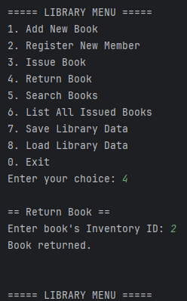

Exception Handling if book never checked out
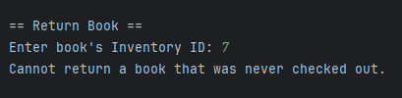

Search Books

This menu allows a user to Search for books.
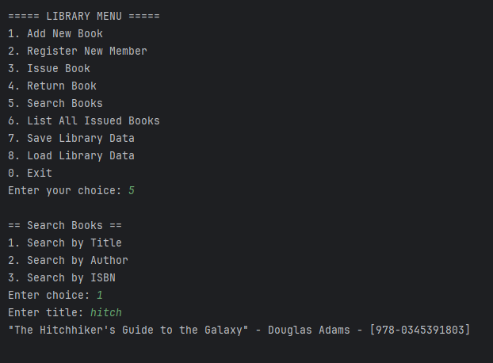
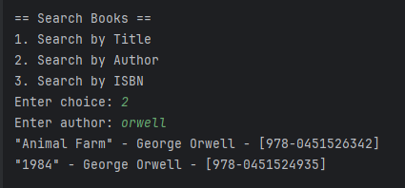
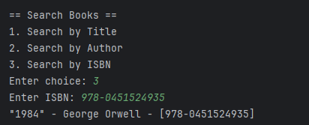

List Issued Books

This menu allows lists all books that have been issued.
The system could be enhanced by providing an option to search for a member by their ID#, but that was not in listed requirements and I was short on time this holiday week. Another improvement could be grouping the books issues by a specific member, that way the member details and the books they have borrowed are all displayed together.

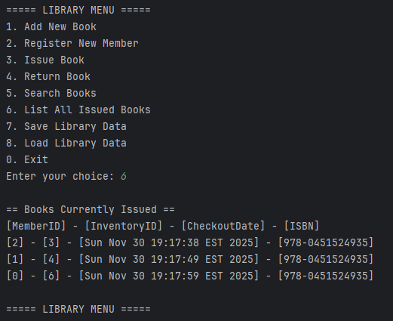

Save and Load Data

This application saves data to disk as the collections are modified to avoid loss of data should the program be closed without saving. Explicit options to save and re-load the data are provided within the menu system though.
The data is saved to several JSON files, which are read in at the start of the program. Attached below are the json files that are saved by this application.

